Class exercise

LC-MS/MS analysis urine samples from human patients gave rise to the following selected negative ion chromatogram at m/z 448.307.
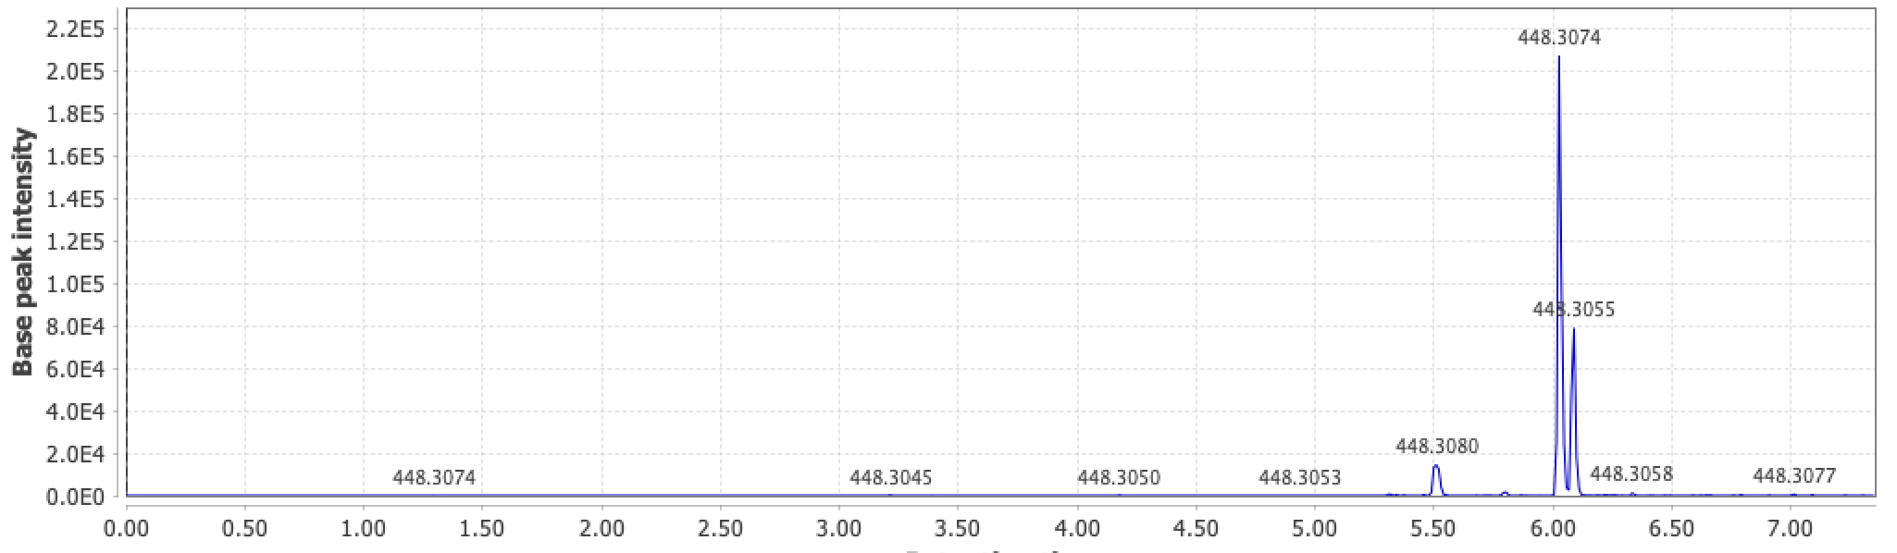
This ion was searched for in the MS/MS data
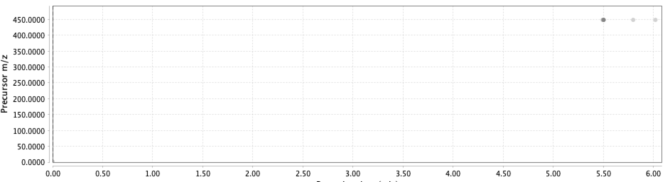
The dots were doubled clicked on to produce these MSMS spectra
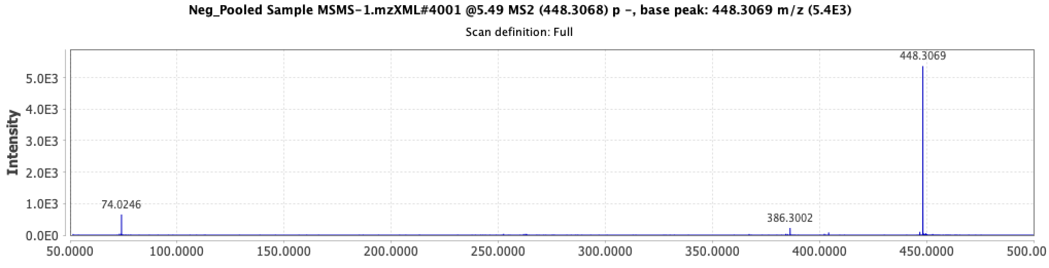

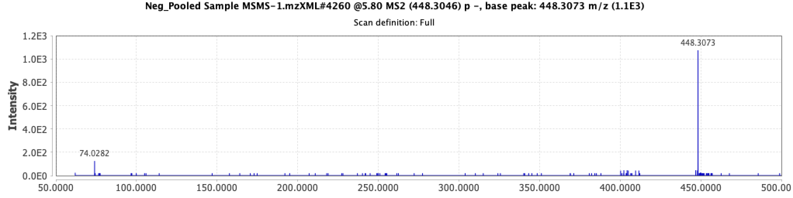
What is this compound? Hint: a search in Google may help. If so, then explain the MSMS spectra. Is the peak eluting at 5.5 min the same as the one at 6.0-6.1?
Another ion was found to be interesting, and it had an ion mass of m/z 528.267 – here’s its ion MSMS spectrum. What is it? The small unmarked peak on the left is m/z 74.026
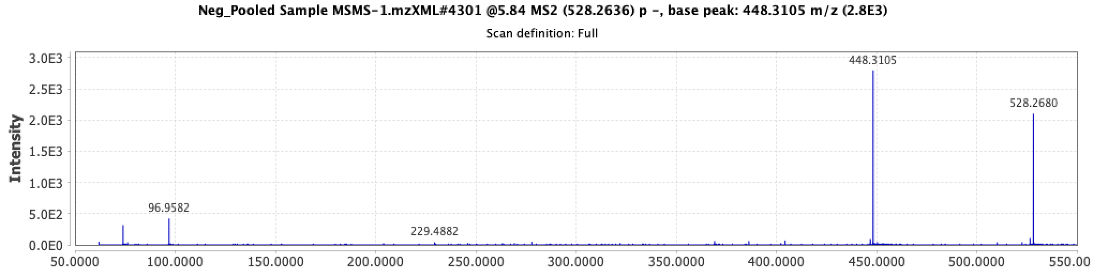
Hint: you have probably noticed the similar ions from the previous MSMS spectra.

Another ion of interest was at m/z 624.335
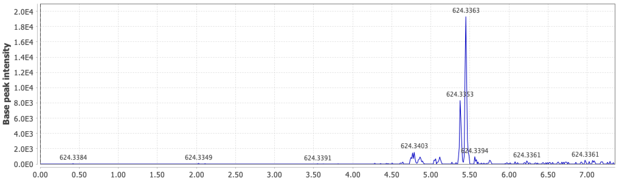
Here’s the search MSMS plot
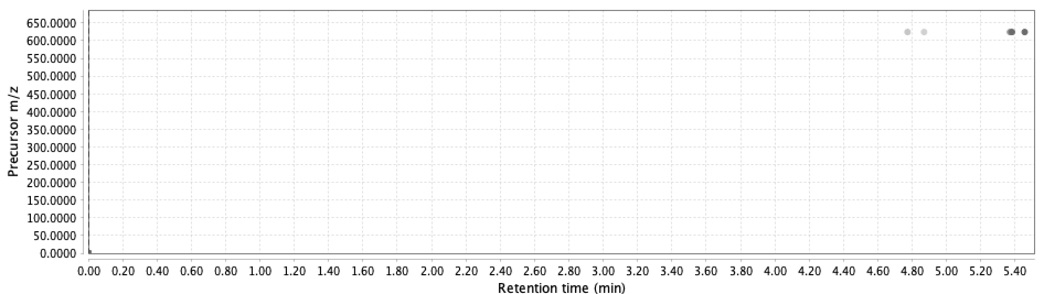
And here’s the MSMS spectrum at ~5.50 min
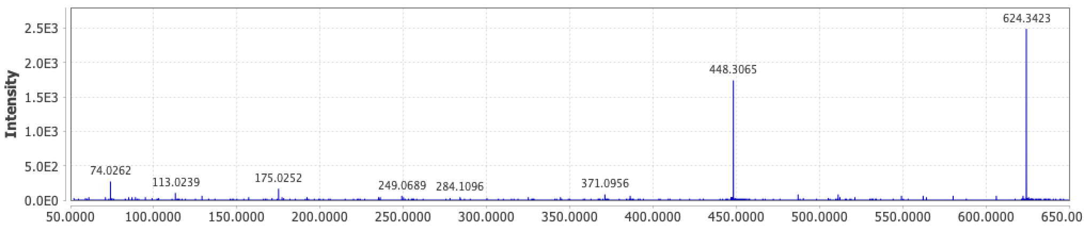
What do you think this compound is? Note the common ion again

